

Digital Thinking

For Local Businesses

**Social Media Business Planning**

**Contents**

Part 1 Business Information   
 Sharing, discussion and understanding the business information

Part 2 Brand   
 Defining the online brand, position and proposition

Part 3 People   
 Understanding the target audiences and their online behaviour

Part 4a Objectives   
 Planning of digital tactics and mechanics

Part 4b Integration   
 Search x Social x Content

Part 5 Activation   
 Stories x Content x Conversation

Part 6 Technology   
 The Conversational Prism

Part 7 Measurement, Evaluation and Innovation  
 Key Performance Indicators

Part 8 Next steps to LIVE  
 Digital strategy and go-to-market plan

**Agenda**

**Digital Tools For Global Growth**

**Social Media Business Planning**

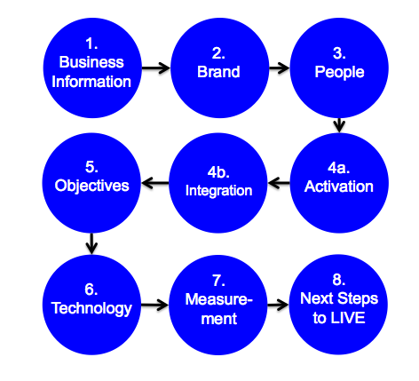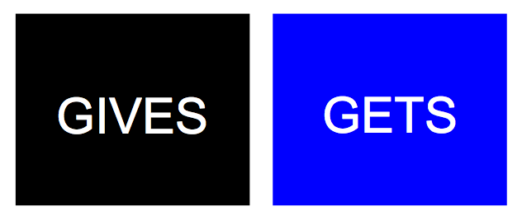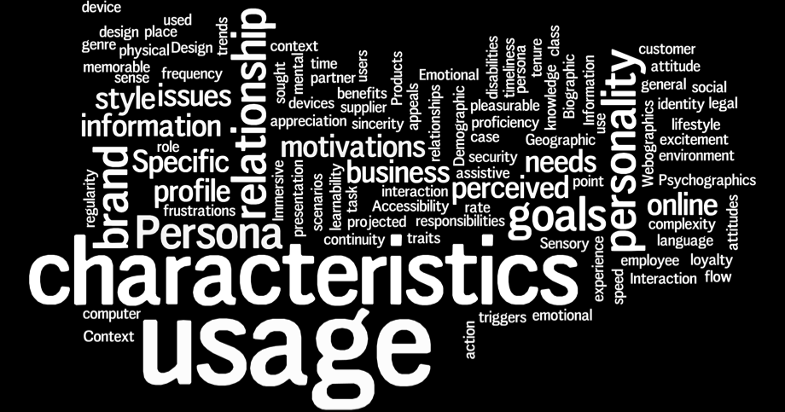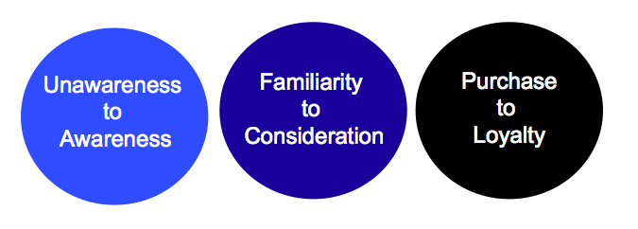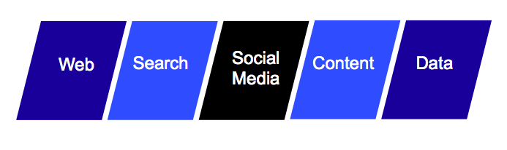 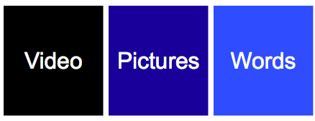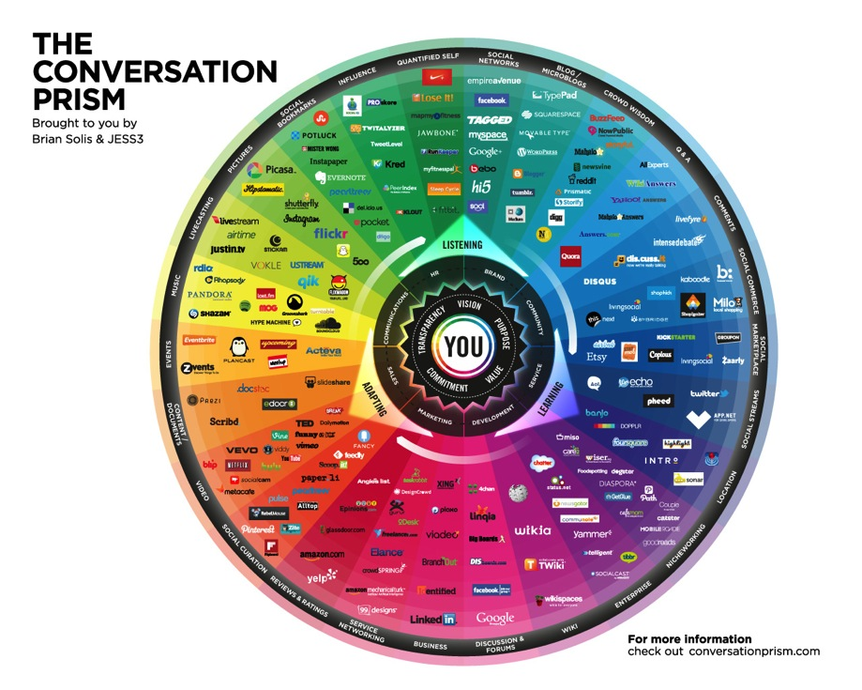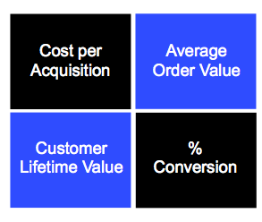

Planning modules

**Deliverable**

Identifying criteria for online success (Key Performance Indicators)

**Deliverable**

* Do you have an up-to-date business plan?
* Does it drop down to a sales and marketing plan?
* Are you aware of the financials; fixed and variable costs, sales and forecasts?
* Do you report against qualitative and quantitative criteria for success?
* Do you know all of your products and services?
* Have you mapped your team and their skills?

**Sharing, discussion and understanding the business information**

**Part 1 Business Information**



Clear articulation of the online brand, position and proposition

**Defining the online brand, position and proposition**

**Deliverable**

* How do the brand, position and proposition translate to online?
* Are your customer’s ‘gives and gets’ clearly articulated?
* What is your brand story?
* Is the brand story consistent across all digital channels?
* What is the number one statement(s) of fact?
* How does the business / brand <face> compare x journalist x BBC Correspondent?
* What is the unique sales proposition vs. competitor set?
* Do you track, audit and evaluate your competition?
* Do you need to complete a social media land grab?

**Part 2 Brand**

Defined target audience groups with initial understanding of online behaviour.

**Deliverable**

* Who currently engages / who do you want to engage with the organisation?
* What are 3D social media personas?
* What information is available from ANY other sources?
* What does your data look like?
* How do you qualify and quantify personas?
* Could you map them out on a wall?
* Could you start messaging segmentation by persona?

**Understanding the target audiences and their online behaviour**

**Part 3 People**

Map out existing sales and marketing activities.

**Deliverable**

Can you map existing target audience information and sales and marketing activities from:

* Unawareness to awareness?
* Familiarity to consideration?
* Purchase to loyalty?

**Planning of digital tactics and mechanics**

**Part 4a Objectives**

Investigate how search, social media and content can be used to achieve commercial and competitive advantage:

**Search**

Identify the most relevant key phrases in Google, Yahoo and Bing according to competitive analysis, language, seasonality, trending, geography intelligence and device (then validate with PPC to ensure absolute accuracy).

**Social media**

The social universe is made up of the positive mentions and deep and meaningful conversations in social space.

**Content**

The content universe is an index of the number of owned vs. user generated content assets that exist in social space and how it moves.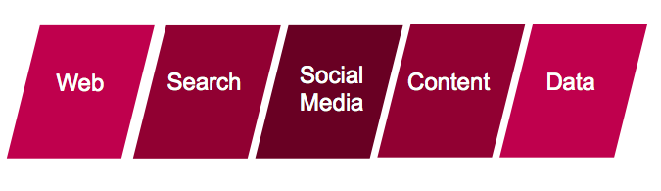



Correlating the relationship between search and sales, positive mentions in social media and customer satisfaction and efficient use of content and reduced media spend.

**Deliverable**

**Search x Social x Content**

**Part 4b Integration**

Understanding what stories need to be told, video x pictures x words created and conversational tone of voice (with etiquette and moderation policy)

**Stories**

What three things are you going to talk about above and beyond the sell?

* Unawareness to awareness
* Familiarity to consideration
* Purchase to loyalty

**Content**

What is digitally efficient content? (Searchable, social and shareable content)

* How to create 60-90 second (mobile accessible) video
* How to upload images and videos
* Could you map your story content plan?
* Atomisation | Drop content on your site and automate sharing it - generate self-made advertising
* Advertising vs. story telling?

**Conversation**

How are you going to engage with the 1:9:90 ratio?

* Talk is cheap ~ Convers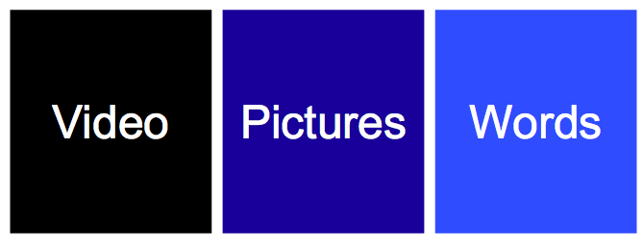ation is expensive!
* Listening and engagement dashboard – workflow to engagement team

12-month story, content production and conversation plan.

**Deliverable**

**Stories x Content x Conversation**

**Part 5 Activation**

Technology plan (Website, search, social media and content)

**Deliverable**

In what web, search, social media and content technology do you exist?

* Considering your personas, do you have the correct technology in place?
* What additional technology do you need? (Website, search, social media and content)
* Can you automate the technology?

**The Conversational Prism**

**Part 6 Technology**

Development of metrics, qualitative and quantitative criteria and understanding next steps.

* What is the cost per acquisition of a new online customer?
* What is the average order value?
* What is the customer lifetime value?
* How can each of the digital tactics and mechanics be measured?
* What is the next level of sophistication that could be added?

Calculation of Key Performance Indicators in measurement dashboard.

**Deliverable**

**Key Performance Indicators**

**Part 7 Measurement, Evaluation and Innovation**

Digital strategy and go-to-market plan.

**Deliverable**

* Agree a budget, scope and lead time of proof of concept?
* Completion and sign off of social media business plan.
* Write the ‘What is actually going to happen’ plan c/w roles, responsibilities and objectives of the team.
* Activate new email signature.

**Digital strategy and go-to-market plan**

**Part 8 Next Steps to LIVE**

**Actionable Insight Digital Marketing Limited**

**Contact Us**

**Contact** Roger Jones

**Web**  www.actionableinsight.co.uk

**Email**  roger@actionableinsight.co.uk

**Phone**  +447970623946

**Twitter**  @rogerjones28

**Linkedin**  /rogerjones28